AP CSP Python with Robots  Algorithms #3 Activity Guide |  | Name:
Robot Code : Solve this problem using the warehouse map and robot code.
1. A robot is programmed using the following code to take a package to a particular chute. It will only drop off the package once the full program code has run. To which chute will the robot deliver the package?  PROGRAM:  REPEAT 3 TIMES:  {  ROTATE_RIGHT()  MOVE_FORWARD(2)  }  Answers:  - 7A  - 5B  - 8C  - No chutes, the robot gets stuck. | 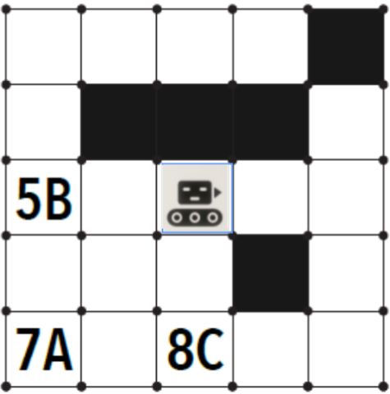
2. This code was designed to make one of the robots pick up the package (P). Which robot makes it to the package?  Program:  REPEAT 2 TIMES:  { MOVE_FORWARD()  MOVE_FORWARD()  ROTATE_RIGHT()  }  REPEAT 4 TIMES:  { MOVE_FORWARD()  }  REPEAT 3 TIMES:  { ROTATE_LEFT()  }  REPEAT 2 TIMES:  { MOVE_FORWARD()  }  - Robot 1  - Robot 2  - Robot 3  - Robot 4 | 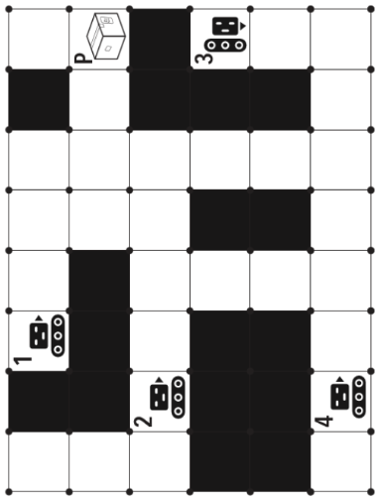
3. A robot just finished delivering a package and needs to return to its docking station. Does this program accurately move the robot back to charge?  Program:  REPEAT UNTIL(dockingstation())  { MOVE_FORWARD()  IF CAN_MOVE(right)  { ROTATE_RIGHT()  }  MOVE_FORWARD()  }  - Yes, the robot makes it back to the charging station.  - No, the robot gets stuck trying to move into a black square.  - No, the robot gets stuck trying to move into the wall.  - No, the robot stops short of the docking station. | 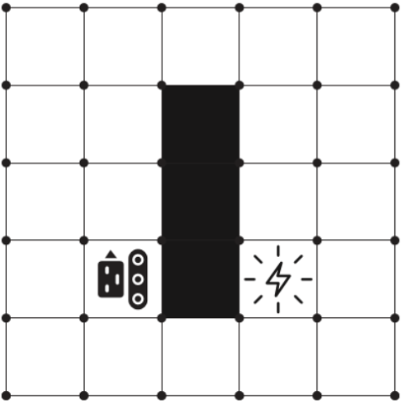
4. A robot is programmed to get to the docking station. Which program should the robot execute in order to get to where it needs to go?  Program 1:  REPEAT UNTIL(dockingstation())  { MOVE_FORWARD()  ROTATE_RIGHT()  MOVE_FORWARD()  }  Program 2:  REPEAT UNTIL(dockingstation())  { ROTATE_RIGHT()  MOVE_FORWARD()  ROTATE_LEFT()  MOVE_FORWARD()  }  - Neither program  - Program 1 only  - Program 2 only  - Both programs | 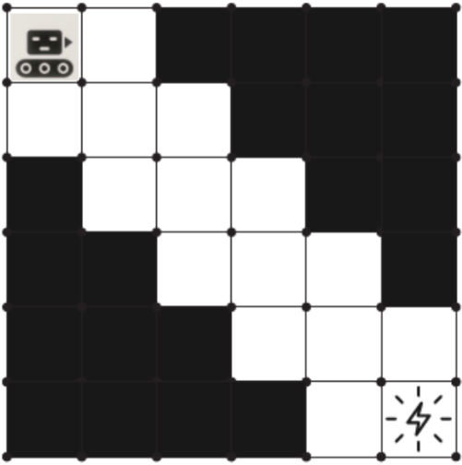
5. This robot needs to pick up package (P) and deliver it to chute C. Will this program be successful?  Program:  REPEAT UNTIL(chuteCreached)  { IF CAN_MOVE(left)  { ROTATE_LEFT()  }  IF CAN_MOVE(forward)  { MOVE_FORWARD()  }  ELSE  { ROTATE_RIGHT()  }  }  - The robot won’t pick up the package or make it to the chute.  - The robot won’t pick up the package but will reach the chute.  - The robot will pick up the package but won’t make it to the chute.  - The robot will pick up the package and make it to the chute. | 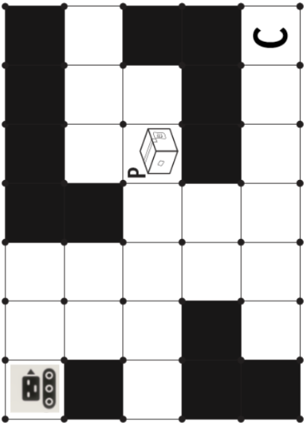
6. It’s time for the robots to return to their docking station. Which robots will get back to the docking station following this code?  Program:  REPEAT UNTIL(dockingstation())  { IF CAN_MOVE(forward)  { MOVE_FORWARD()  }  IF CAN_MOVE(left)  { ROTATE_LEFT()  }  IF CAN_MOVE(right)  { ROTATE_RIGHT()  }  }  - Robot A  - Robot B  - Both robots  - Neither robot | 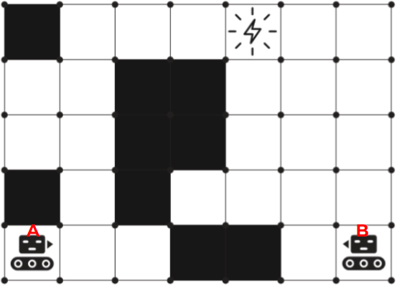
Challenge Problems. The next two problems use the repair robot. It moves around the warehouse floor constantly checking for broken down robots. When he drives over the same space as another robot, he checks to see if it is broken and fixes it if necessary.
7. The repair robot is searching the warehouse floor for broken robots. There are a few robots that need assistance. Using this program, which robots will it fix?    Program:  REPEAT FOREVER  { IF CAN_MOVE(forward)  { MOVE_FORWARD()  }  ELSE  {ROTATE_RIGHT()  }  }  - Robots 1, 2 and 3  - Only robots 1 and 2  - Only robots 1 and 3  - No robots | 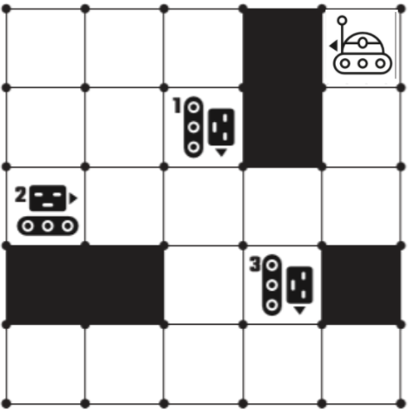
There are three broken-down robots which are not moving. If the repair robot follows this program, which robots will it manage to fix?  Program:  REPEAT FOREVER  { IF CAN_MOVE(right)  { ROTATE_RIGHT()  MOVE_FORWARD()  }  IF CAN_MOVE(left)  { ROTATE_LEFT()  MOVE_FORWARD()  }  IF CAN_MOVE(forward)  { MOVE_FORWARD()  }  }  - It can fix 1 and 2 but not 3.  - It can fix 1 and 3 but not 2.  - It can fix 1 only.  - It can fix 2 only. | 